Project-Phase 1
  - Deadline: Day 26/07/2026 @ 23:59
[Total Mark is 5]

Computer Networks
DS360

Instructions:
- You must submit two separate copies (one Word file and one PDF file)using the Assignment Template on Blackboard via the allocated folder. These files must not be in compressed format.
- It is your responsibility to check and make sure that you have uploaded both the correct files.
- Zero mark will be given if you try to bypass the SafeAssign (e.g., misspell words, remove spaces between words, hide characters, use different character sets, convert text into imageor languages other than English or any kind of manipulation).
- Email submission will not be accepted.
- You are advised to make your work clear and well-presented. This includes filling your information on the cover page.
- You must use this template, failing which will result in zero mark.
- You MUST show all your work, and text must not be converted into an image, unless specified otherwise by the question.
- Late submission will result in ZERO mark.
- The work should be your own, copying from students or other resources will result in ZERO mark.
- Use Times New Roman font for all your answers.
Student Details: CRN:
Name:Hassan Al-Matrood  Name: Mohammed Alqarni  Name:Ameer Alsulami |  | ID:S230009954  ID:S230038517  ID:S240011275

Project Instruction
Project Objective:
Design, configure, and test a network setup in Packet Tracer to successfully transmit data packets between devices in different LANs across two separate WANs (WAN 1 and WAN 2).
Group Details
- Group Size = Maximum of 3 Members.
- One group member (group leader/coordinator) must submit theproject report on blackboard. Marks will be given based on your submission and quality of the contents.
Project Report
- The project is divided into two phases:
  - Phase 1(Mid project Progress Report)
  - Phase 2(Final project Report)
- This report is for Phase 1. In this report, you should complete all the requirements for Phase 1 only.
- Each Report will be evaluated according to the marking criteria

Project Description(Common to Phase 1 and Phase 2)
Learning Outcome(s):
Demonstrate protocol configuration, network-addressing schemes and analyze packet transmission for the Local and Wide Area Networks.

A university operates two campuses: a Main Campus and a Branch Campus. Each campus network is treated as a separate WAN site. Your task is to design and configure, in Cisco Packet Tracer, a network that successfully transmits data packets from a device in any LAN of WAN 1 (Main Campus) to a device in any LAN of WAN 2 (Branch Campus). Each WAN contains 2 LANs, and each LAN has 3 end devices.

Network Design Requirements:
- WAN 1 (Main Campus):
  - Contains LAN 1 (Computer Lab) and LAN 2 (Admin Office).
  - Each LAN has 3 devices (PCs or laptops) connected through a switch.
  - Assign private IP addresses to the devices in each LAN (e.g., use 172.16.10.0/24 for LAN 1 and 172.16.20.0/24 for LAN 2).
  - Connect each LAN to a router (Router 1).
- WAN 2 (Branch Campus):
  - Contains LAN 3 (Library) and LAN 4 (Faculty Office).
  - Each LAN has 3 devices (PCs or laptops) connected through a switch.
  - Assign private IP addresses to the devices in each LAN (e.g., use 172.16.30.0/24 for LAN 3 and 172.16.40.0/24 for LAN 4).
  - Connect each LAN to a router (Router 2).
- WAN Connection:
  - Connect Router 1 and Router 2 using a serial link to simulate a WAN connection.
  - Assign IP addresses to the serial interfaces (e.g., 10.10.10.1/30 for Router 1 and 10.10.10.2/30 for Router 2).

Configuration Details:
- Assign IP Addresses:
  - Configure IP addresses, subnet masks, and default gateways for all devices in each LAN. Example:
    - LAN 1: 172.16.10.0/24, Default Gateway: 172.16.10.1 (Router 1's interface).
    - LAN 2: 172.16.20.0/24, Default Gateway: 172.16.20.1 (Router 1's interface).
    - LAN 3: 172.16.30.0/24, Default Gateway: 172.16.30.1 (Router 2's interface).
    - LAN 4: 172.16.40.0/24, Default Gateway: 172.16.40.1 (Router 2's interface).
- Router Configuration:
  - Configure IP addresses on the LAN and WAN interfaces of both routers. Example:
    - Router 1:
      - LAN 1 Interface: 172.16.10.1/24
      - LAN 2 Interface: 172.16.20.1/24
      - WAN Interface (Serial): 10.10.10.1/30
    - Router 2:
      - LAN 3 Interface: 172.16.30.1/24
      - LAN 4 Interface: 172.16.40.1/24
      - WAN Interface (Serial): 10.10.10.2/30
- Enable Routing:
  - Configure static routes or a dynamic routing protocol (e.g., RIP) on both routers to ensure communication between WAN 1 and WAN 2.

Phase 1 Requirements
5 Marks
Students are required to submit a short mid progress report, which must include the following:
- Work completed this period (2 marks): This includes the installation of Cisco Packet Tracer, and a study of Packet Tracer for creating nodes, using different types of links (copper straight-through, copper cross-over, serial DCE/DTE), and assigning IP addresses.
  - Note: You must show a screenshot of the installation of Packet Tracer (with your system visible, e.g., date/time or username). (1 mark)
  - Give a description of the objectives and advantages of using Packet Tracer for this project. (1 mark)
- One key decision made during this period (1 mark): For example, your choice of IP addressing scheme, choice of routing method to study, or division of work among group members. Explain briefly why the decision was made.
- One problem encountered (1 mark): Describe one genuine problem faced so far (technical or organizational) and its current status (resolved / in progress).
- Plan for the next period (0.5 mark): Briefly list the tasks you plan to complete before the final submission (e.g., building the topology, configuring routers, testing with ping).
- Each group member's input/participation (0.5 mark): State each member's name and their specific contribution during this period.

Version History / Commit Log Requirements (Common to Both Reports)
Students must document and submit their project history/timestamps using a live, editable link:
- Written report: Submit a shared Google Doc or Word Online link (sharing set to "Anyone with the link can view") along with your final PDF report. The link must show the progress of the students' work with timestamps/screenshots.
- Code/data/configuration files: Submit Packet Tracer files (.pkt) and any configuration scripts via a GitHub or GitLab repository link (the coordinator may choose a repository suitable for the course). The repository must show a commit history reflecting incremental progress. Commit regularly (at minimum once per week), with clear, descriptive commit messages.
A separate section in the report must be added and named "Project Artifacts" to include all links, for example:
  - Live report document (with edit history): [link]
  - GitHub/GitLab repository (with commit history): [link]
  - Packet Tracer project file (.pkt): [link or attached]
What NOT to do: Students must not write their report elsewhere and paste the final version in at the last minute. They also must not make a single commit containing the entire project. Both are treated as red flags regardless of the quality of the final work.

Important Notes
- AI use: Students may use AI tools (ChatGPT, Claude, Copilot, Gemini, etc.) only for brainstorming approaches, debugging small errors, or proofreading text. AI must not be used to generate analysis, write configuration logic, or produce substantial portions of the report or project files. Any permitted AI use must be disclosed in the Reflection section. Undisclosed AI use, or AI use beyond this scope (disclosed or not), will result in a zero grade for the entire project.
- Any submission lacking a valid, inspectable version/commit history, or showing evidence of AI generation or plagiarism, will receive a zero grade for the entire project.
- Failure to submit the mid progress report as required, or submission of reports found to be fabricated, copied, or AI-generated, will result in a zero grade for the entire project.
- The mid progress report should be concise including screenshots.
- The same shared document link and repository submitted in Phase 1 must continue to be used for Phase 2, so that the full project history is visible in one place.

1. Phase 1 Report Overview
This mid-project report records the preparation completed for a two-campus network in Cisco Packet Tracer. The planned design connects the Main Campus and Branch Campus through a point-to-point serial WAN link. Each campus contains two local area networks (LANs), and every LAN contains three end devices connected through a switch. Phase 1 focuses on installing and studying Packet Tracer, understanding the required devices and links, preparing the addressing plan, selecting a routing approach, and organizing the work that will be completed before the final submission.

  - Project objective
The objective of this project is to design and plan a network that enables IP communication between the Main Campus LAN and the Branch Campus LAN. During Phase 1, the team prepared the network design, IPv4 addressing plan, and project documentation. Network configuration and testing will be completed in the next phase.

  - Phase 1 marking-criteria coverage
Phase 1 requirement | Evidence included in this report | Status
Work completed this period | Installation evidence placeholder; study of nodes, links, and IPv4 addressing plan | Prepared
Objectives and advantages of Packet Tracer | Section 4 | Complete
One key decision | IP addressing plan and routing approach in Section 5 | Complete
One problem encountered | Packet Tracer setup issue and current status in Section 6 | Confirm with group
Plan for next period | Implementation plan for the next phase in Section 7 | Complete
Member participation | Team members' contributions in Section 8 | Complete
Project Artifacts | Report, GitHub repository, and design documents in Section 9 | Links required

2. Proposed Network Design
The proposed network design includes one router at each campus. Router 1 is planned to connect the Computer Lab and Admin Office, while Router 2 is planned to connect the Library and Faculty Office. The two routers will be connected through a serial DCE/DTE point-to-point link using the 10.10.10.0/30 network. Four /24 LAN subnets were selected to keep the departments logically separate and provide a clear IPv4 addressing plan for the next phase.

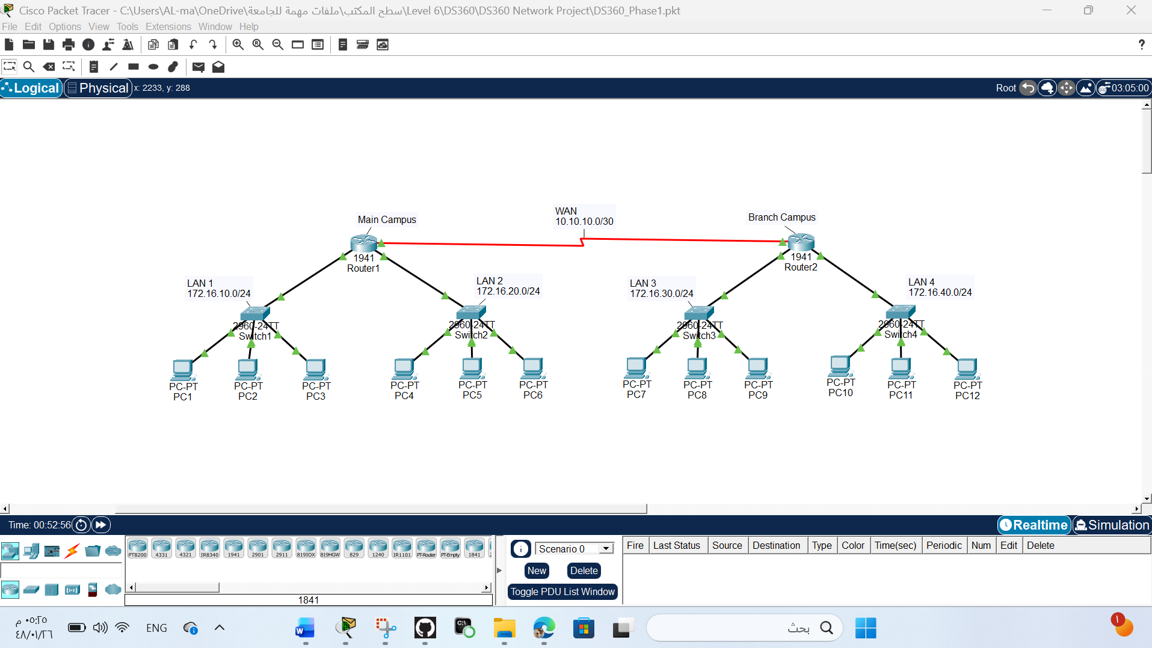

Figure 1. Proposed Packet Tracer topology and addressing structure.

3. Work Completed During This Period
3.1 Cisco Packet Tracer installation
Cisco Packet Tracer was selected as the simulation environment for the project. During this period, the software was installed and opened to confirm that the Logical workspace, device selection area, cabling tools, Realtime mode, Simulation mode, and device configuration windows were available. The required installation evidence must be captured on the same computer used by the group.
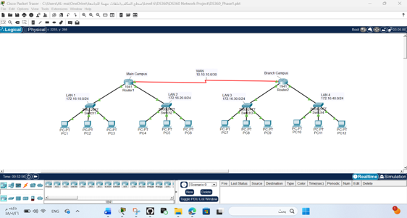
Figure 2: Cisco Packet Tracer installed and running on the local computer.
3.2 Study of nodes, links, and IPv4 settings
The group reviewed the purpose and placement of the devices needed for the topology. Practice included adding devices to the workspace, changing display names, connecting devices, exploring the Desktop > IP Configuration window on a PC, and understanding the basic router configuration interface.
Item studied | Purpose in the project | Key point learned
PC or laptop | Acts as an end device in each LAN | Needs a unique IP address, /24 mask, and the local router address as default gateway.
Layer 2 switch | Connects the three end devices in one LAN | For this project, the switch forwards Ethernet frames; no management IP is required for basic connectivity.
Router | Routes packets between local LANs and the remote campus | Each connected network requires a router interface with an IP address.
Copper straight-through | PC-to-switch and switch-to-router links | Used between unlike Ethernet device types in the planned topology.
Copper cross-over | Studied as an alternative Ethernet link | Traditionally used between like devices; it is not required in the proposed topology.
Serial DCE/DTE | Connects Router 1 and Router 2 | Used to connect the two routers through a point-to-point WAN link.
4. Objectives and Advantages of Using Packet Tracer
4.1 Objectives
- Represent the four LANs and two campus routers in one clear logical workspace.
- Practice selecting the correct devices, modules, interfaces, and cable types before implementation.
- Prepare the IPv4 addressing plan for all LANs and the WAN connection.
- Understand how communication will take place between the Main Campus and Branch Campus.
- Prepare the network design for implementation and testing in the next phase.

4.2 Advantages
Packet Tracer is suitable for this project because it provides a visual environment for designing and planning computer networks. It allows the group to build and modify the network topology without purchasing physical routers, switches, modules, or cables. Different design ideas can be tested safely, and saved .pkt files help document the project's progress.
Packet Tracer also includes Realtime and Simulation modes, which the team studied during this phase. These features help users understand how networks operate and prepare the group for the configuration and testing tasks that will be completed in the next phase.

5. One Key Decision Made
The group selected a structured private IPv4 addressing scheme and static routing for the planned implementation. The four LANs were assigned the networks 172.16.10.0/24, 172.16.20.0/24, 172.16.30.0/24, and 172.16.40.0/24. The third octet identifies the LAN number, while .1 is reserved for the router interface and .11–.13 are planned for the three end devices. The serial connection is planned to use the 10.10.10.0/30 network because a point-to-point link requires only two usable IP addresses.
Static routing was selected because the proposed network includes only two routers and two remote LANs behind each router. It provides a simple and organized routing approach that is suitable for a small network. A dynamic routing protocol such as RIP was also studied as an alternative, but static routing was considered more appropriate for this project's size and requirements.

6. One Problem Encountered
During the preparation stage, the team faced some difficulty understanding how the serial connection between the two routers would be configured in Cisco Packet Tracer. We reviewed the Packet Tracer documentation and discussed the required devices, serial modules, and connection types before proceeding with the implementation. Current status: The issue has been identified, and the team is prepared to complete the configuration during the next phase.

7. Plan for the Next Period
- Build the complete network topology with two routers, four switches, and twelve end devices.
- Connect all LAN devices and establish the WAN connection using a Serial DCE/DTE link.
- Configure IPv4 addresses, subnet masks, and default gateways for all PCs and router interfaces.
- Configure static routing to enable communication between the Main Campus and Branch Campus.
- Test network connectivity using ping and tracert to verify communication between all LANs.
- Use Simulation Mode to observe packet transmission and verify the network design.
- Update the GitHub repository, save the latest .pkt files, and prepare the final project report.

8. Group Member Input and Participation
The Phase 1 tasks were divided among the three group members as shown below. Each member contributed to the project based on their assigned responsibilities and participated in preparing the progress report.

Group Member | Primary role | Assigned responsibilities
Hassan Al-Matrood | Coordinator and documentation lead | - Coordinated the project planning and team tasks.  - Created the GitHub repository and prepared the project documentation.  - Prepared the network topology and project documentation.  - Reviewed the Phase 1 report before submission.
Mohammed Alqarni | Topologyand cabling lead | - Contributed to planning the network topology.  - Reviewed the required network devices and cable types.  - Assisted in preparing the topology design.  - Reviewed the project documentation with the team.
Ameer Alsulami | Addressing and routing lead | - Prepared the IPv4 addressing plan.  - Studied the routing approach for the proposed network.  - Reviewed the network design and provided feedback.  - Helped prepare the project for the implementation phase.

9. Project Artifacts
Live Report Document:
https://docs.google.com/document/d/1ChwMgi82KIDwldD4KX7cP26tcpmA4fDOYIahLXBURts/edit?usp=sharing
GitHub Repository:
https://github.com/H-Matrood/DS360-Network-Project.git
Packet Tracer Project:
DS360_Phase1.pkt (Attached)
References
- Cisco Networking Academy. Cisco Packet Tracer User Guide.
- Cisco Systems. Cisco Packet Tracer Documentation.
- GitHub Docs. Getting Started with GitHub.https://docs.github.com/
- Cisco Networking Academy. Introduction to Networks (ITN).https://www.netacad.com/
- RFC Editor. RFC 791 – Internet Protocol (IPv4).https://www.rfc-editor.org/rfc/rfc791

9.1 Version history / commit log
Date | Commit / version | Description | Status
Jul 11, 2026 | Commit 1 | Initial project setup and network topology | Completed
Jul 11, 2026 | Commit 2 | Add initial project documentation in README.md | Completed
Jul 11, 2026 | Commit 3 | Updated network topology and documentation | Completed
Jul 11, 2026 | Commit 4 | Updated team members in README | Completed

3. Reflection
During Phase 1, our team learned how to use Cisco Packet Tracer and gained a better understanding of network devices, IPv4 addressing, and basic network design. We worked together to plan the topology, prepare the addressing plan, organize the project documentation, and manage our work using GitHub. These activities gave us a clear understanding of the project requirements and prepared us for the implementation phase.
One challenge we faced was understanding the serial connection between the two routers and selecting the appropriate routing approach. By reviewing the project requirements, Cisco Packet Tracer documentation, and discussing the design as a team, we were able to improve our understanding and prepare for the next phase of the project.
AI Assistance Disclosure: ChatGPT was used only as a supporting tool to improve the organization, wording, grammar, and formatting of the report, explain networking concepts, and review the documentation. All project decisions, network design, technical work, and final report content were reviewed and approved by the project team.

